Question 1:
Write a program that calculates the total cost of items in a shopping cart. The program should accept the number of items and the price per item, then compute and display the total cost.

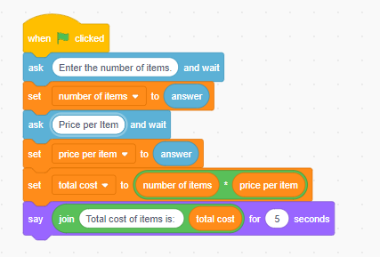

Question 2:
Make a program that asks the user for a number and then tells if the number is divisible by 3 and 5 at the same time.

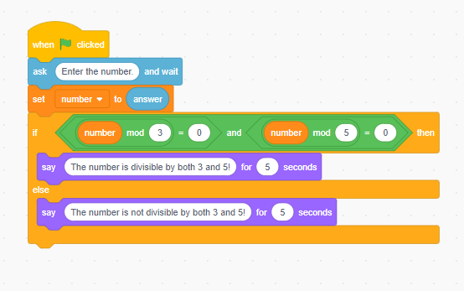

Question 3:
Ask the user for the number of people and the number of pizza slices they will eat. The program should calculate the total number of slices needed and then say, "You need to order at least [total slices] slices of pizza!"

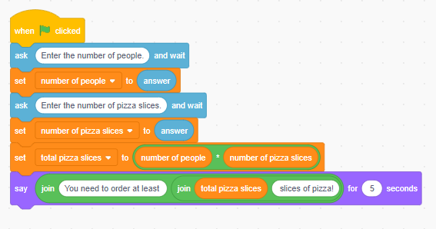

Question 4
Create a program where the user has to open a secret door.
1. Ask, "What is the secret color?" The correct answer is "blue".
2. If the answer is right, ask, "What is the magic number?" The correct answer is "7".
- If both answers are correct, the sprite says "The door is open!"
- If the first answer is right but the second is wrong, the sprite says "The door stays shut."
- If the first answer is wrong, the sprite immediately says "The door won't open."

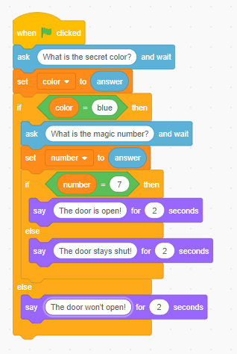

Question 5:
Make a quiz game with 3 questions. For every correct answer, the score should go up by 1. At the end, show the player’s total score.

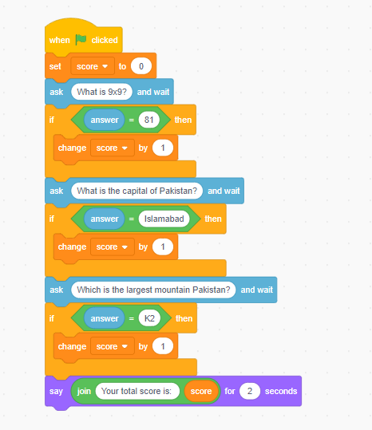

Question 6:
Create a simple game where the Sprite asks a question: “What is 5 + 5?”
- If the answer is wrong, the program keeps asking again and again until the user gives the correct answer.
- When the answer is correct, the cat says: “Well done!

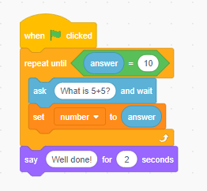

Question 7:
Make a program where the sprite says the multiplication table of any number the user enters.
(Example: if the user enters 4 → it shows 4, 8, 12 … up to 10 steps.)

